Solar Home Systems project

Nobody Village, South Africa

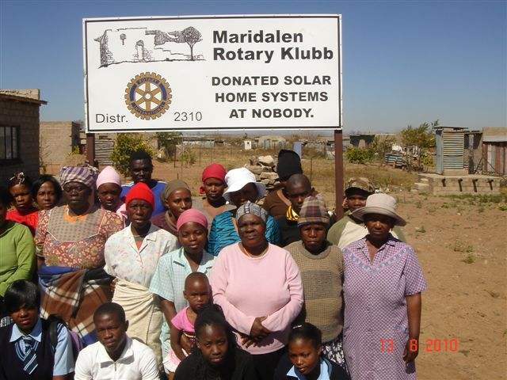

Project Report – Phase 1 (25 SHS installations)

June 2010

Contact:  Tommy Fernandes  Solenergi Uten Grenser - Solar Energy Unlimited  tommy.fernandes@c2i.net | 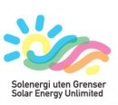
Trygve Fjetland  Maridalen Rotary Klubb  tfjetlan@online.no | 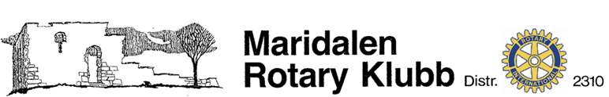

Contents
1 About this document 3
2 Introduction 3
3 Solar Vision’s challenges 4
4 Delivering solar power in a distributed concept 5
5 The SHS Concession and how it works 7
6 Summary – simple goals – huge impact - mission accomplished 8
7 Images after completion of installation 9
Here photos from Nobody village will be inserted Error! Bookmark not defined.
More photos etc. from Nobody Village or last page Error! Bookmark not defined.

About this document
This document captures the experiences from deploying a Solar Home Systems – SHS as part of the South African government’s rural electrification program.

This document references the completion of the first phase and is prepared by Solenergi Uten Grenser – Solar Energy Unlimited hereafter referred as SUG – SEU.

Introduction
Solenergi Uten Grenser – Solar Energy Unlimited SUG – SEU is an organization created to address the service-platform challenge in providing solar energy to paying customers at the bottom of the pyramid. By drawing on mechanisms popularized in the concept of Corporate Social Responsibility (CSR), SUG - SEU connects donors directly to an existing vehicle for grassroots involvement. The effort is additive and grows the momentum to create paying customers.

Execution of such ambitious goals through a donor funded activity in a location so remote from Norway would not have been feasible without having access to a deployment and operational vehicle in the location. Solar Vision is our partner of choice. They meet the fundamental criteria of competence and experience. We deem their track record and business foundation as sustainable over time and the strongest reason thereby to be the best service provider for the rural customer.

Solar Vision – SV has as a mission the goal to be acknowledged as the preferred non-grid service provider. Through the recognition of the basic energy needs of people in remote areas, who are mostly poor, SV has indulged to provide appropriate technology through sound management to uplift their living conditions. Solar electricity provides a vehicle for social upliftment, job creation, education, health, entertainment and access to information via radio, television and telecommunication.

Company Mission

- To provide a reliable product at an affordable price.
- To provide previously disadvantaged people with basic electricity.
- To acknowledge the importance of the customers through good customer service.
- Through regular and efficient maintenance ensure the product remains operational.
- To employ people from the rural areas in which Solar Vision is operating.
- To capacitate people employed by Solar Vision to grow along with the company.

Company Values

To conduct business with integrity and transparency for the benefit of all parties involved.

Solar Vision’s challenges
In 2003 Solar Vision plugged in the first SHS. The elected 6 concessionaires accelerated in start/stop fashion but in accordance with the action plan. But then one very important player - Eskom/Shell - withdrew from the game that proved to have serious consequences

The DME started putting in smaller plugs to compensate - one concessionaire never got started and another one went bankrupt. 3 concessionaires survived:

Raps – Nuon
KES – Edf/Total
Solar Vision

In 2006 the plug was pulled out completely and SV had to adapt its activity to the new situation!

Customer base - growth and decline

 | Annual Connections | Cumulative connected
2002 Dec | 693
2003 Dec | 2,943 | 3,636
2004 Dec | 3,111 | 6,747
2005 Dec | 4,090 | 10,837
2006 April | 1,250 | 12,087
2009 May | Declining customer base | 7,850

SV’s concession has to manage without a ‘rich uncle’ with deep pockets, but the new shareholders are determined not to give up. SV will continue to work towards the original concession goal of 50 000 solar home systems. It is our hope that the rich Norwegian government will realise that they could play a huge role here with a very small one time contribution in a rural electrification fund. That would help them politically achieve multiple goals like poverty eradication and CO2 emission reduction in a shorter period of time. The environmental impact will be high if not higher than alone pumping BILIIONS into CO2 cleansing and rainforest preservation. The political prestige and environmental image of NORWAY would also be a sustainable one by participation of one of the many Norwegian energy entities or development funding agencies in a ready made project. After all Norway believed in this by starting it and which by all means is a success!

Rural electrification in a 100% decentralized mode can only be financed by a capital subsidy through a strong fund and a long and sustainable period of time and the use of Renewables. Concessionaires must expect that both sides in an agreement stick to their commitments

SV will strengthen its business model accepting contributions from private Donor monies from abroad in the form of village adoption and individual households serve as a important part of a revival of a private-public partnership based on CSR as an integral part of the financing model. SUG – SEU and this first village adoption by Maridalen Rotary Klubb in Oslo, Norway is a shining example that we hope others will follow.

Delivering solar power in a distributed concept
Solar Vision has a positive impact on the community it operates in. It is a textbook example of how PV technology can quickly raise the living standard of people in rural areas and developing countries. At the same time, it benefits the environment immediately and in the future, allowing these areas to leapfrog over conventional polluting energy sources.
Our standard small SHS (Solar Home System) system of one 50Wp solar panel with a battery will operate 4 fluorescent lamps and one 14" black-and-white DC television set, a radio or cassette player and a small DC fan for at least 4 hours every night for the lights and television. The system size can be increased by increasing the size/number of the solar panels and battery bank. SHS systems are typically used in rural houses, schools, health centers and offices.

The standard SHS kit consists of:

- A solar panel/module to transform light energy from the sun into electricity
- A solar deep cycle battery bank to store the power generated by the solar panel
- A charge controller to protect the battery from over-charge and over discharge
- An appropriate number of DC lights (fluorescent tubes or U-type energy saving lights)
- Connecting cables and electrical accessories such as switches, sockets etc.
- An inverter unit incase of a need for AC power from the system

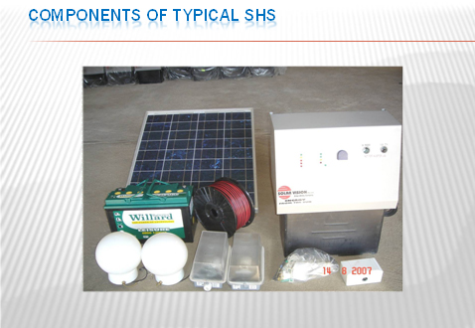
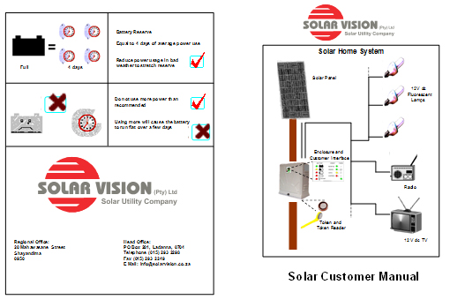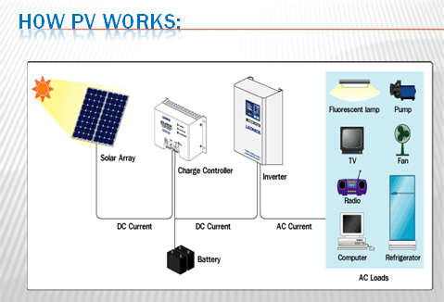

The project was initiated on 03.04.2010 and work on the site commenced around 15.04.2010. When all applications were received from Nobody Village and approved, the 25 SHS were installed, tested and confirmed commissioned on 28.05.2010.

The SHS Concession and how it works

Capital subsidies per installation usually came from government. Solar Vision installed over 10 500 solar home systems since 2003 on this basis, which is maintained based on the monthly fee for service contribution of the customers. Due to large scale grid electrification in the Solar Vision area of operations the company already has lost over three thousand customers to grid electrification.

With the donations that Solar Vision receives the solar panel of such a removed system is recovered and re-deployed to keep the capital cost per installation down. Systems installed, from donations received, will become the property of the owner not to be removed again in case such a customer should receive grid electricity. As the owner of the system he can deal with it according to his own discretion. He will not make any monthly maintenance contributions anymore and also forfeit the free basic electricity subsidy that will now be converted to 50 free kilo watt hour for his grid electricity consumption.

The systems installed are based on applications that Solar Vision received from particular customers in the designated village. The customer information of relevant customers are captured on the System Master Station (database) containing amongst other the name, physical address, GPS co-ordinates, identity number and cell phone number of the customer. A solar home system through a commissioning process is then allocated to each customer after whom a technical team with installers does the actual installation of a solar home system to a specific customer according to the meters commissioned.

Every new customer is registered with Solar Vision and eligible to purchase monthly credit on a fee for service basis from Solar Vision. The customer contribution is ZAR 28 per month and is not based on consumption but a fee for service to keep his solar system in a functional condition. In the same relation and according to the principle of Free Basic Electricity (FBE) for all, the local municipalities make a monthly contribution of ZAR 40 for each non-grid customer. Since the date of installation Solar Vision has got a 20 year obligation to maintain such a system in exchange for a monthly maintenance fee.

Summary – simple goals – huge impact - mission accomplished

Mr. Tommy Fernandes, founder of SUG – SEU started the process of informing Maridalen Rotary Klubb in 4Q 2009. An active member, Mr. Trygve Fjetland was the front runner of a proposal made to the governing body of the Rotary club. Mr. Fernandes was invited to give a presentation at a board meeting of the club’s executive board and answer all applicable questions.

In February 2010, SUG – SEU was informed that a positive decision to adopt a village with 50 households, was passed by the board. The decision was to contribute financially for 25 SHS with refurbished solar panels to be installed in 2010 and 25 SHS in 2011. Maridalen Rotary Klubb and SIG – SEU signed an agreement confirming the above and which included a project plan. The village chosen was Nobody Village in Capricorn – Polokwane – Limpopo.

In mid April 2010, Mr Fernandes visited Solar Vision in Polokwane as part of other activities and was informed appropriately of the progress with planning and the installations.

This project report confirms with pleasure that SUG – SEU through Solar Vision has accomplished this first phase task as it was assigned to by the agreement with Maridalen Rotary Klubb. The next phase will be undertaken in 2011 when Maridalen Rotary Klubb gives us the task of executing the second phase of installing 25 new SHS in Nobody Village.

Images after completion of installation

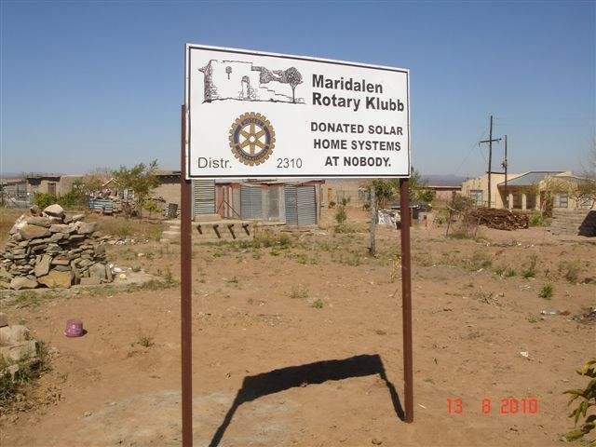

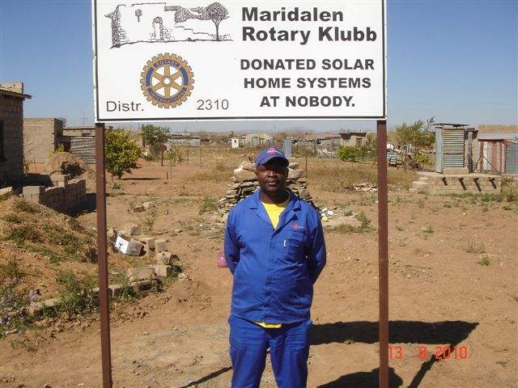
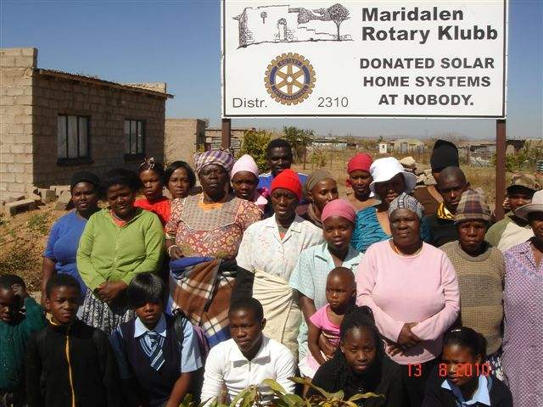
www.givesolarpower.com
www.solarvision.co.za
www.insitesolar.com

